**Assignment 1: Launch an EC2 instance using Terraform and Install Jenkins, Java and Python in Instance**

Step 1: Install Terraform using below command

wget -O- https://apt.releases.hashicorp.com/gpg | sudo gpg --dearmor -o /usr/share/keyrings/hashicorp-archive-keyring.gpg

echo "deb [signed-by=/usr/share/keyrings/hashicorp-archive-keyring.gpg] https://apt.releases.hashicorp.com $(lsb_release -cs) main" | sudo tee /etc/apt/sources.list.d/hashicorp.list

sudo apt update && sudo apt install terraform

O/P

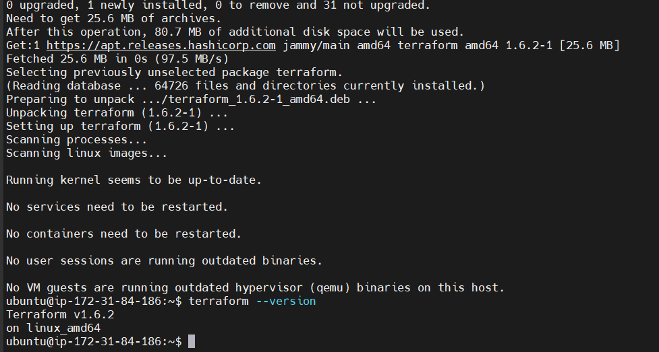

Step 2: Use AWS Api Access Key from practice lab

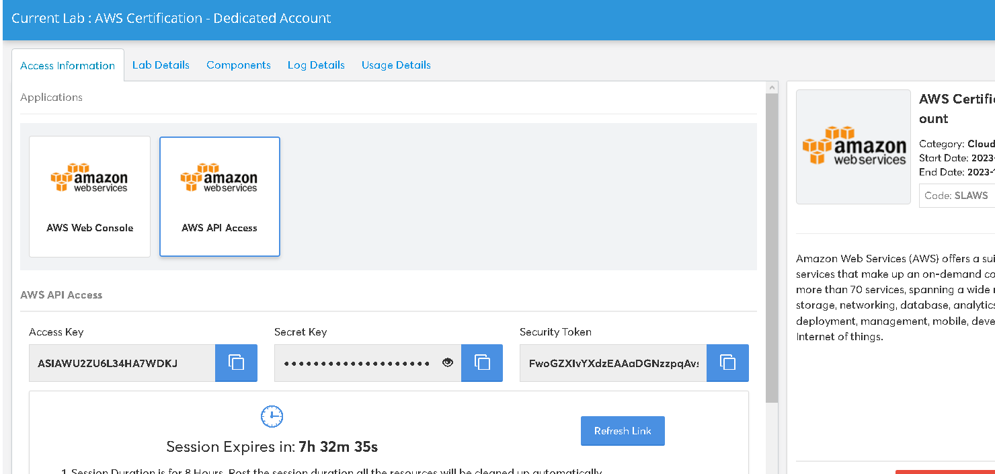

Step 3: Now create Cred.tf and Main.tf file

Cred.tf file is contain all security credentials like access key, token key and security token

$ Vi cred.tf

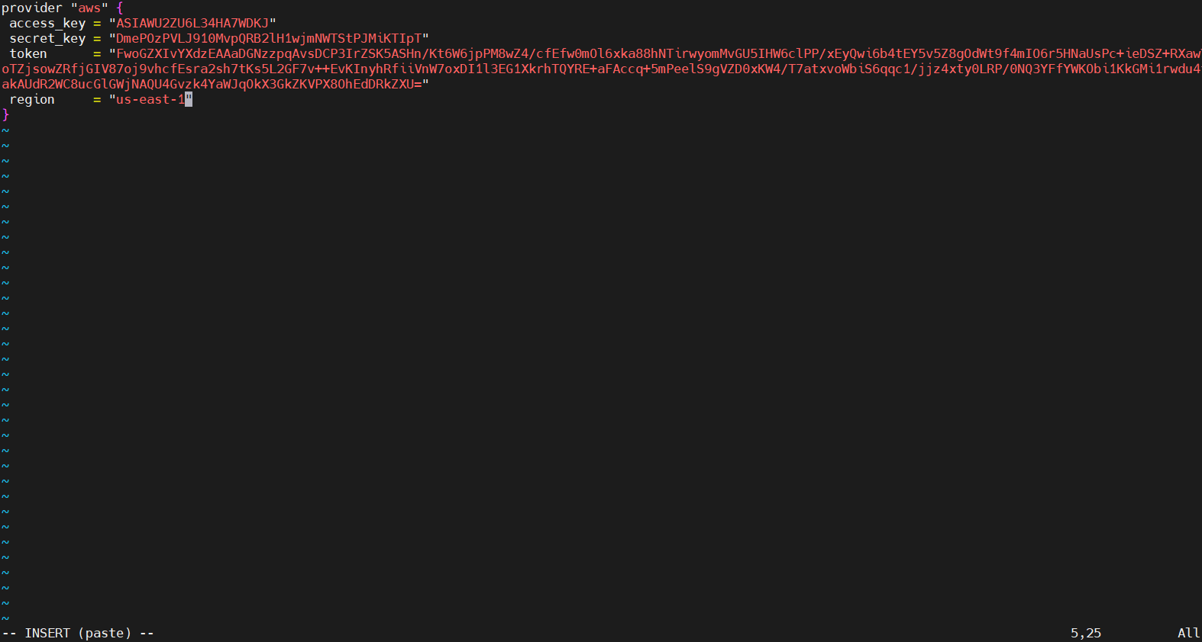

Now create main.tf file It contain what resource we need to setup like s3 bucket, EC2 Configuration

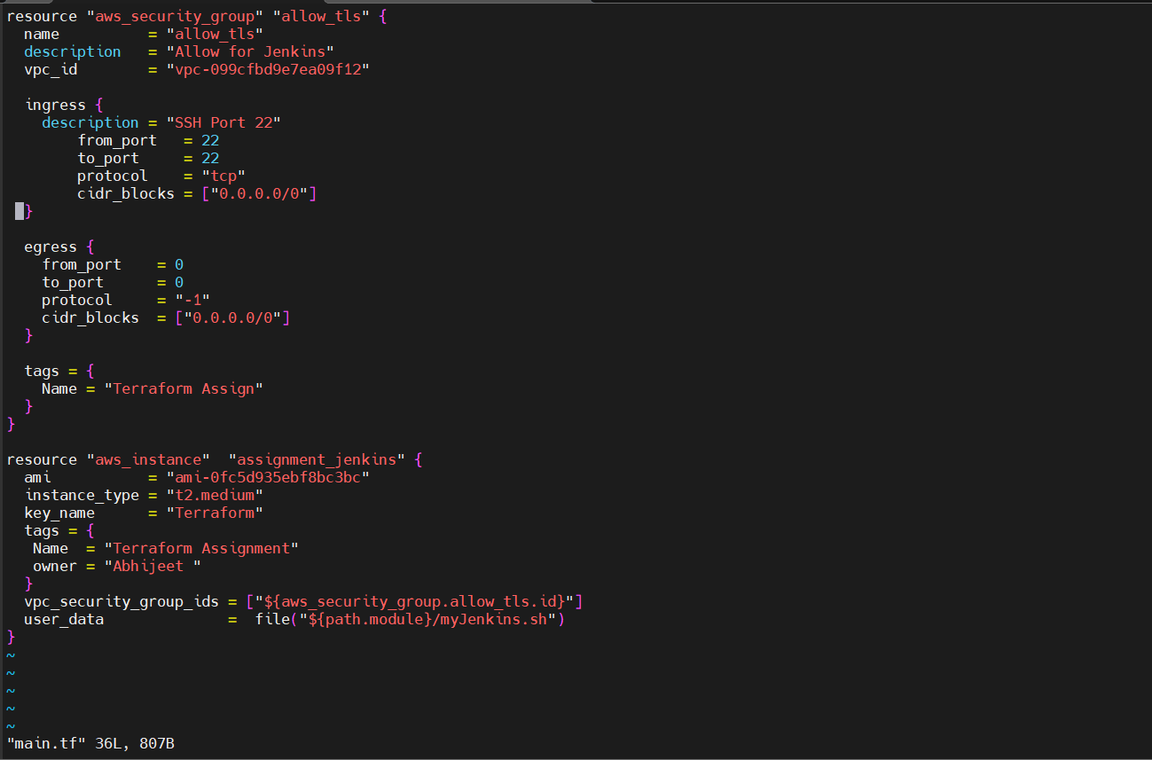

Step 4: Create Script file myJenkins.sh and Install Java, Jenkins and Python

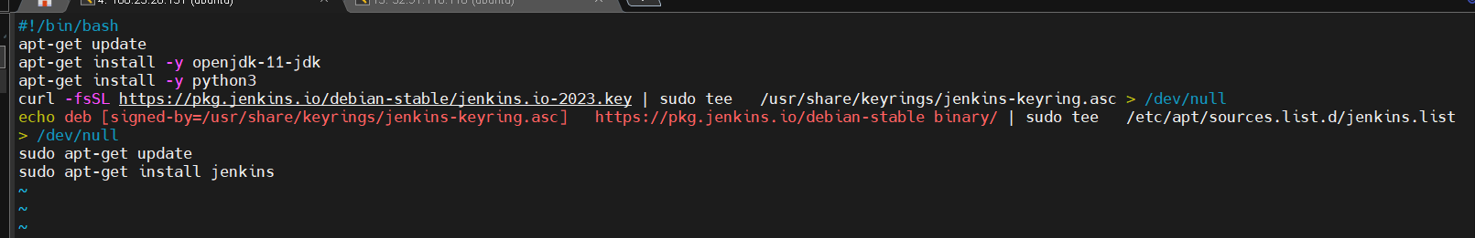

Step 4: No Initialize Terraform using below command

$ terraform init

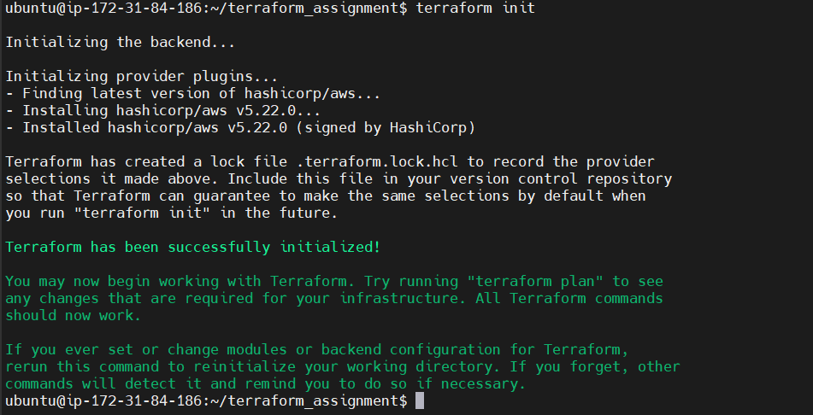

Step 5: Validate Terraform using below command

$ terraform validate

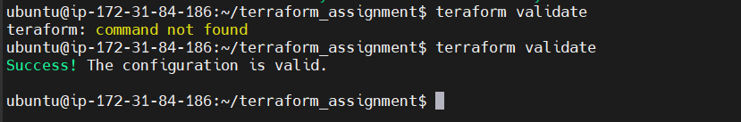

Step 6: Now enter Terraform apply command to apply configuration

$ terraform apply

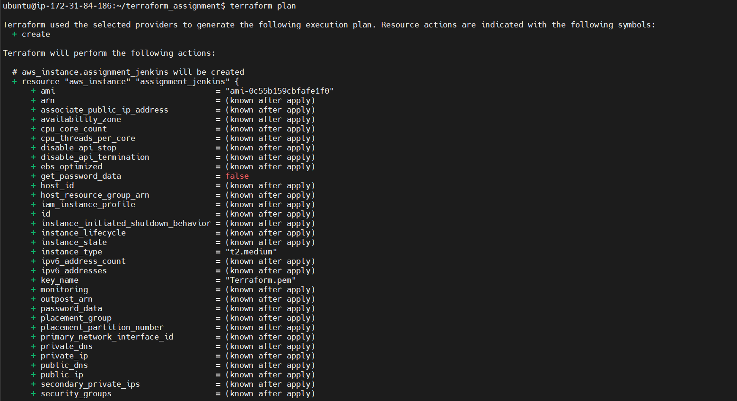

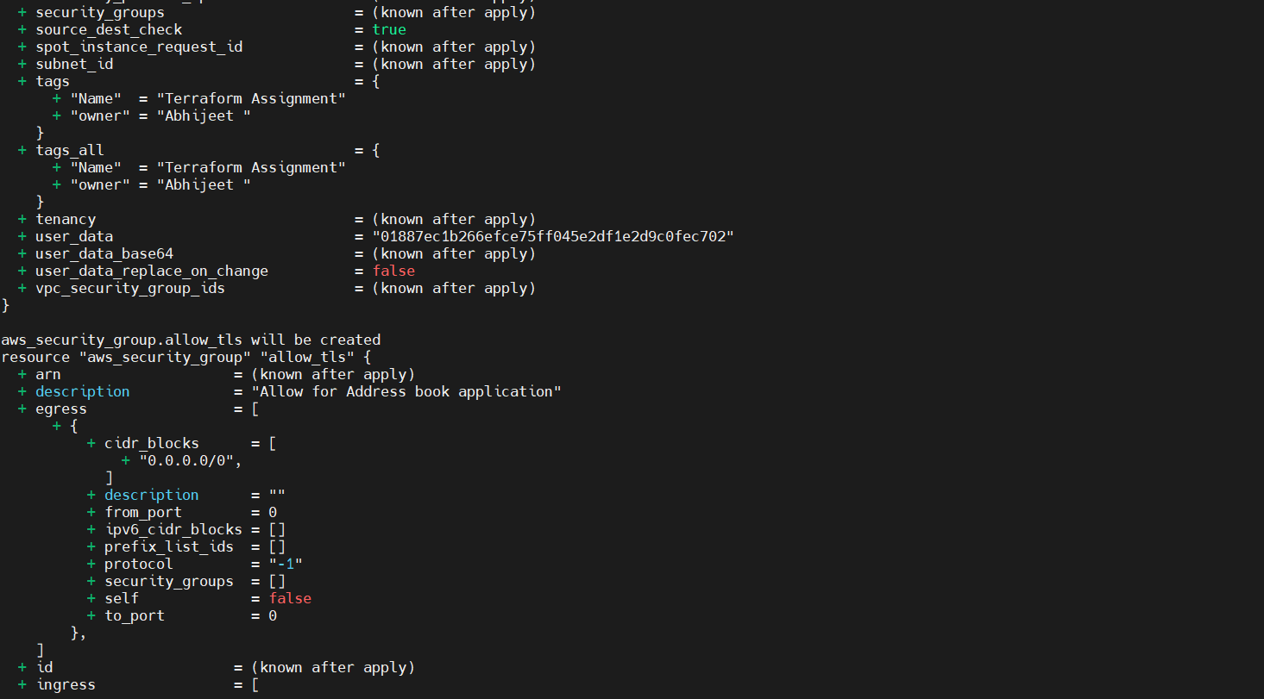

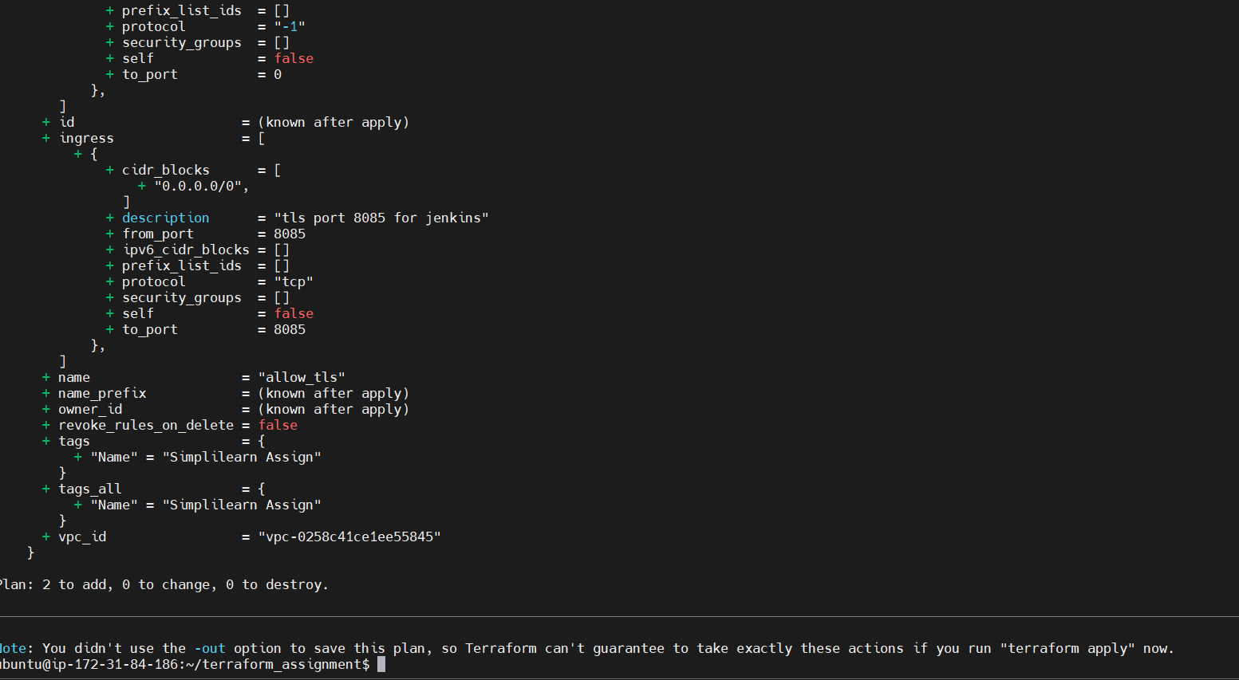

Step 7: Step 6: Now enter Terraform apply

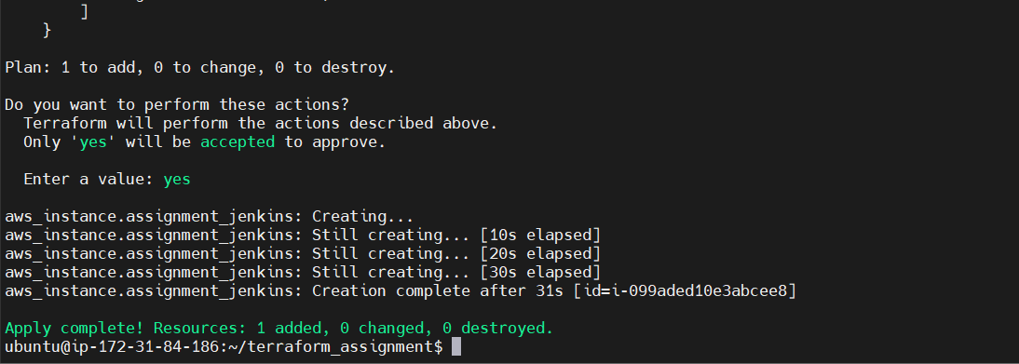

Output :

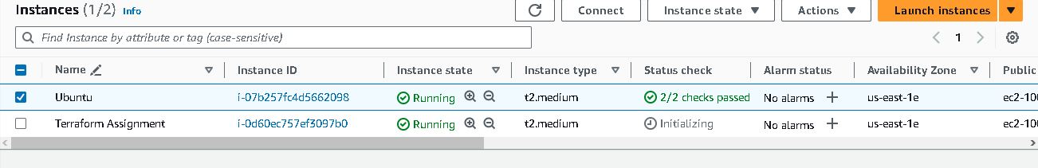

Successfully configured Java, Python and Jenkins

